**Problem Statement**

**Product Dissection for top leading Platforms**

Welcome to this case study on dissecting and designing products for top leading platforms. In this case study, you will delve into the intriguing world of schema design for a prominent platform of your choice. Your task is to choose a top leading platform, research its features, and meticulously craft a schema design that encapsulates the essence of its functionality. By focusing on key entities, attributes, and relationships, you will gain invaluable insights into how data architecture drives the platform's effectiveness.

**Step 1: Choose a Leading Platform**

Select a leading platform of your choice, which could span various domains such as social media, e-commerce, finance, or any other industry. This choice will form the foundation of your exploration into its schema design.

**Step 2: Research:**

Thoroughly research the platform you have selected. Investigate its core features, functionalities, and user interactions. Identify the top features that define its user experience and contribute significantly to its popularity.

**Step 3: Product Dissection and Real-World Problems solved by the platform**

In this step, you will meticulously analyse the platform's standout features and how they provide innovative solutions to real-world challenges. By identifying key functionalities that resonate with users, you'll unravel how the platform effectively addresses problems and enhances user experiences. This dissection will serve as the foundation for understanding how the schema design aligns with the platform's core objectives.

**Step 4: Case Study on the real-world problems and approach to solving them**

In this pivotal step, you will expand on the real-world challenges uncovered in Step 3 through a comprehensive case study. Delve into specific instances where users encountered difficulties and showcase how the platform's unique features provided effective solutions. By dissecting the approach taken by the platform to overcome these challenges, you'll gain a deeper appreciation for the platform's user-centric design philosophy and how it shapes the schema design.

**Step 5: Schema Design Based on Top Features**

Based on the features you have identified, craft a schema design that reflects the platform's data structure. Focus on the key entities, attributes, and relationships that underpin the chosen features. Your schema should capture the essence of how the platform organises and utilises its data.

**Step 6: Rationale Behind the Design**

While creating the schema design, consider the rationale behind the platform's choices. Reflect on why certain entities and relationships were chosen and how they align with the platform's goals. This will help you understand the strategic decisions driving the schema's architecture.

**Step 7: Create an ER Diagram**

Utilise tools like the Miro platform or similar applications to create an illustrative Entity-Relationship (ER) diagram. This diagram should vividly depict the entities, attributes, and relationships present within your schema design. The ER diagram will serve as a visual representation of your insights.

**Step 8: Presentation of Findings**

Present your findings in a clear and concise manner. Showcase your understanding of how the schema design impacts the platform's functionality and user experience. Explain how your chosen features are integrated into the schema and how the schema's structure supports the platform's objectives.

**Task Details:**

1. **Answer Submission:** Your submission should include well-structured solutions for all provided questions related to product schema designs.
2. **Video Creation:** Create an informative and engaging video where you thoroughly explain the Case Study.
3. **Depth and Clarity:** Ensure your solutions are detailed and showcase your understanding of product schema design principles. Similarly, in the video, provide clear explanations that are easy to understand for a wide audience.
4. **Creativity Encouraged:** You are welcome to utilise visuals, diagrams, or creative elements to enhance the clarity and impact of your explanations.

**Note:**

1. Duplicate this document and proceed to write your solutions and prepare your video.
2. Include the video link in this document before final submission.

Best of luck in completing this project and showcasing your prowess in dissecting and designing product schema for leading platforms! **For reference, we have also conducted a case study on Instagram, which you can find below. This case study will provide you with valuable insights into how schema design plays a pivotal role in shaping the functionality and success of a prominent platform.**



**Product Dissection for 𝕏**

**Company Overview:**

Company 𝕏, formerly known as Twitter, is a renowned social media platform founded in 2006. It revolutionized online communication by introducing the concept of microblogging, allowing users to share thoughts and updates in 280 characters or less. Over the years, 𝕏 has become a global hub for news, conversations, and cultural movements, serving millions of users worldwide. In a landmark acquisition in 2022, visionary entrepreneur Elon Musk acquired Twitter and named it 𝕏, heralding a new era for the platform. Under his leadership, Company 𝕏 is poised to undergo transformative changes and innovations, shaping the future of social media and digital communication.

**Product Dissection and Real-World Problems Solved by 𝕏:**

𝕏 isn't just a place to share updates, it's a hub where people connect, talk about what's happening, and make a difference. Whether it's spreading news quickly, joining movements, or chatting with favourite celebrities, 𝕏 brings everyone together in one big conversation. It's like a global community where everyone has a voice, and together, we can change things for the better.

**Case Study: Real-World Problems and 𝕏's Innovative Solutions**

**Problem 1: Information Overload**

**Real-World Challenge:** In an era of information abundance, users often struggle to filter through the noise and find relevant updates efficiently.

**Company 𝕏's Solution:**

𝕏's character limit encourages brevity, allowing users to convey information concisely. The platform's real-time feed ensures users receive timely updates, while features like algorithms and trending topics help surface relevant content amidst the vast sea of information.

**Problem 2: Crisis Communication**

**Real-World Challenge:** During emergencies or crisis situations, disseminating accurate information quickly is crucial for public safety and awareness.

**Company 𝕏's Solution:**

𝕏 serves as a critical tool for crisis communication, enabling governments, organizations, and individuals to share real-time updates and coordinate response efforts. The platform's reach and immediacy make it invaluable during emergencies, facilitating rapid dissemination of vital information.

**Problem 3: Amplifying Voices and Fostering Activism**

**Real-World Challenge:** Amplifying marginalized voices and driving social change requires platforms that enable widespread visibility and engagement.

**Company 𝕏's Solution:**

𝕏 empowers marginalized communities and activists to amplify their voices and catalyse change. Hashtags, retweets, and trending topics provide avenues for advocacy and mobilization, allowing users to raise awareness and effect societal change on a global scale.

**Problem 4: Building Communities and Facilitating Dialogue**

**Real-World Challenge:** Building inclusive communities and fostering constructive dialogue across diverse perspectives is essential for societal progress.

**Company 𝕏's Solution:**

𝕏 facilitates community building and dialogue through features like lists, chats, and threaded conversations. Users can connect with like-minded individuals, engage in meaningful discussions, and gain exposure to diverse viewpoints, fostering empathy and understanding.

**Conclusion:**

In conclusion, 𝕏 has emerged as a powerful platform that addresses various real-world challenges with its innovative features. From tackling information overload through concise communication to serving as a vital tool for crisis communication during emergencies, 𝕏 plays a crucial role in facilitating dialogue, amplifying voices, and fostering activism. By empowering marginalized communities, enabling widespread visibility, and promoting constructive dialogue, 𝕏 continues to shape societal progress and foster a sense of community in an interconnected world.

**Top Features of 𝕏:**

1. **Tweets:** Users can share thoughts, news, and updates within a 280-character limit.
2. **Retweets:** Users can amplify others' tweets to their followers, promoting information dissemination
3. **Likes:** Users can express appreciation for tweets by liking them, signalling agreement or approval.
4. **Hashtags:** Users can categorize tweets and participate in broader conversations around specific topics.
5. **Replies:** Users can respond to tweets publicly, initiating conversations and engaging with other users.
6. **Lists:** Users can curate lists of accounts based on interests, facilitating content discovery and community building.
7. **Trends:** 𝕏 highlights popular topics and hashtags, providing insights into current events and conversations.

**Schema Description:**

𝕏's schema consists of entities such as Users, Tweets, Retweets, Likes, Hashtags, Replies, Lists, and Trends. Relationships between entities enable users to engage with content, connect with others, and participate in conversations.

**User Entity:**

* **User_ID (Primary Key):** A unique identifier for each user.
* **Username:** The user's chosen handle or username.
* **Bio:** A brief description of the user.
* **Location:** The user's specified location.
* **Join Date:** The date when the user joined 𝕏.

**Tweet Entity:**

* **Tweet_ID (Primary Key):** A unique identifier for each tweet.
* **User_ID (Foreign Key referencing User Entity):** The user who posted the tweet.
* **Content:** The text content of the tweet.
* **Media:** Optional media attachments such as photos or videos.
* **Date_Posted:** The date and time when the tweet was posted.

**Retweet Entity:**

* **Retweet_ID (Primary Key):** A unique identifier for each retweet.
* **Original_Tweet_ID (Foreign Key referencing Tweet Entity):** The original tweet being retweeted.
* **Retweeter_User_ID (Foreign Key referencing User Entity):** The user who retweeted the tweet.
* **Date_Retweeted:** The date and time when the retweet was posted.

**Like Entity:**

* **Like_ID (Primary Key):** A unique identifier for each like.
* **Tweet_ID (Foreign Key referencing Tweet Entity):** The tweet being liked.
* **Liker_User_ID (Foreign Key referencing User Entity):** The user who liked the tweet.
* **Date_Liked:** The date and time when the like was registered.

**Hashtag Entity:**

* **Hashtag_ID (Primary Key):** A unique identifier for each hashtag.
* **Tag:** The text content of the hashtag.

**Reply Entity:**

* **Reply_ID (Primary Key):** A unique identifier for each reply.
* **Parent_Tweet_ID (Foreign Key referencing Tweet Entity):** The tweet being replied to.
* **Replier_User_ID (Foreign Key referencing User Entity):** The user who posted the reply.
* **Content:** The text content of the reply.
* **Date_Replied:** The date and time when the reply was posted.

**List Entity:**

* **List_ID (Primary Key):** A unique identifier for each list.
* **Owner_User_ID (Foreign Key referencing User Entity):** The user who created the list.
* **List_Name:** The name or title of the list.
* **Description:** A brief description of the list's purpose or content.

**Trend Entity:**

* **Trend_ID (Primary Key):** A unique identifier for each trend.
* **Tag:** The text content of the trend.
* **Date_Started:** The date when the trend started trending.

**Relationships:**

* **Users post Tweets:** Each user can post multiple tweets. (One to Many relationship)
* **Users retweet Tweets:** Users can retweet multiple tweets, and each tweet can be retweeted by multiple users. (Many to Many relationship)
* **Users like Tweets:** Users can like multiple tweets, and each tweet can be liked by multiple users. (Many to Many relationship)
* **Users reply to Tweets:** Users can reply to multiple tweets, and each tweet can have multiple replies. (Many to Many relationship)
* **Users create Lists:** Users can create multiple lists, and each list can be created by one user. (One to Many relationship)
* **Tweets have Hashtags:** Tweets can contain multiple hashtags, and each hashtag can be associated with multiple tweets. (One to Many relationship)
* **Tweets are part of Trends:** Tweets can become part of trending topics, and each trend can encompass multiple tweets. (One to Many relationship)

**ER Diagram:**

Let's construct an ER diagram that vividly portrays the relationships and attributes of the entities within the company 𝕏's schema. This ER diagram will serve as a visual representation, shedding light on the pivotal components of 𝕏's data model. By employing this diagram, we will gain a clearer grasp of the intricate interactions and connections that define the platform's dynamics.

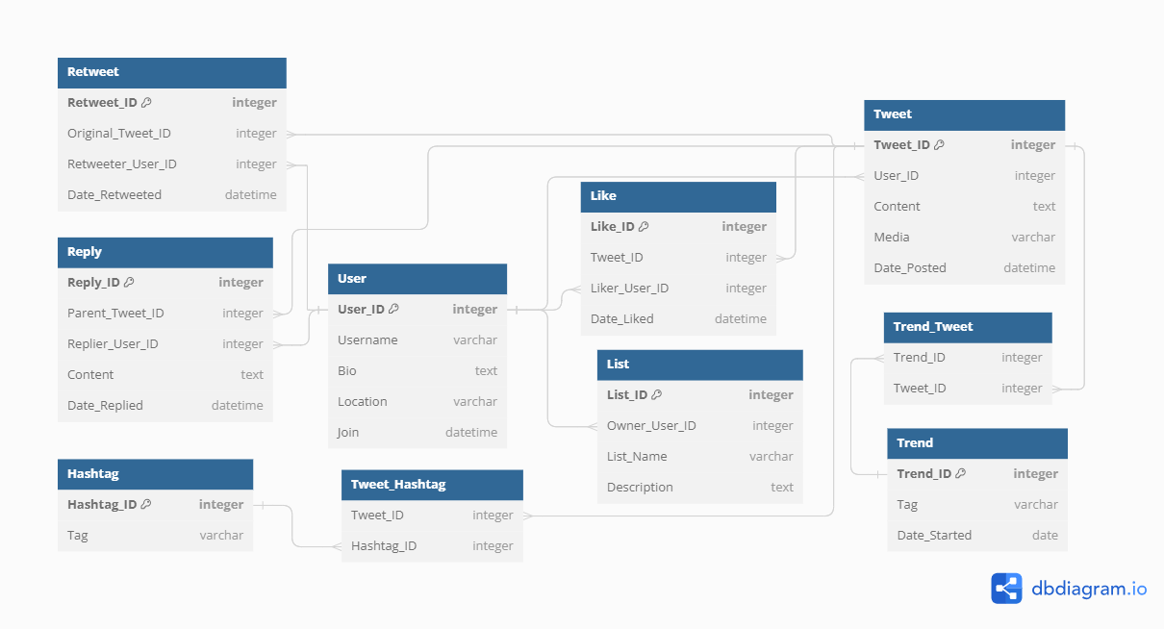

### **Conclusion:**

In this case study, we've delved into the schema design and Entity-Relationship diagram for Company 𝕏, formerly known as Twitter. Company 𝕏 has redefined social media, reshaping how individuals engage, share, and connect online. Through our analysis, we've uncovered the intricate data model underpinning Company 𝕏's platform, including entities such as users, tweets, retweets, likes, hashtags, replies, lists, and trends. This schema serves as the foundation for Company 𝕏's seamless functionality, enabling real-time communication, information dissemination, and community building. As we dissect Company 𝕏's schema, we gain deeper insights into its role in shaping the digital landscape and fostering meaningful connections on a global scale, reaffirming its status as a transformative force in the world of social media.

**Github:** [**https://github.com/meetGAUROB/Product-Dissection-for-X**](https://github.com/meetGAUROB/Product-Dissection-for-X)